PROJECT REPORT
SMART FAQ CHATBOT USING NLP

Submitted for:CodeAlpha Artificial Intelligence Internship

Submitted By
- Name: narsipuram pravallika
- College Name: vignan’s institute of engineering for women
- Internship Domain: Artificial Intelligence
- Project Title: Smart FAQ Chatbot Using NLP
- Submission Date: 13-05-2026

1️⃣ Introduction
Artificial Intelligence and Natural Language Processing (NLP) are transforming the way users interact with systems and applications. Many organizations receive repeated customer questions regarding services, products, support, timings, pricing, and account-related issues. Answering these questions manually consumes time and resources.
To solve this problem, a Smart FAQ Chatbot was developed using NLP techniques. The chatbot accepts user questions, preprocesses the text using NLP, and matches the question with the most relevant FAQ using cosine similarity.
The chatbot instantly returns the best matching answer through a professional and user-friendly interface.
This project was developed as part of the CodeAlpha Artificial Intelligence Internship.

2️⃣ Objectives
The main objectives of this project are:
- To develop an AI-powered FAQ chatbot.
- To understand Natural Language Processing concepts.
- To preprocess user text using NLP techniques.
- To implement cosine similarity for question matching.
- To provide instant answers to users.
- To design a responsive and attractive chatbot interface.
3️⃣ Problem Statement
Many websites and organizations receive repetitive questions from users. Providing manual responses for every query can be time-consuming and inefficient.
Therefore, there is a need for an automated chatbot system that can understand user questions and provide accurate answers instantly.
This project solves the problem by creating an NLP-based FAQ chatbot that automatically finds and returns the most relevant answer.
4️⃣ Technologies Used
Python | Backend Programming
NLTK | Natural Language Processing
Scikit-learn | Cosine Similarity
Streamlit | Frontend User Interface
HTML/CSS | UI Design
VS Code | Development Environment
5️⃣ System Requirements
Hardware Requirements
- Processor: Intel i3 or above
- RAM: 4GB minimum
- Storage: 1GB free space

Software Requirements
- Python 3.10+
- VS Code
- Streamlit
- NLTK
- Scikit-learn
- Internet Connection

6️⃣ Project Architecture
User Question
↓
Text Preprocessing using NLP
↓
Tokenization & Cleaning
↓
Cosine Similarity Matching
↓
Best FAQ Match
↓
Display Response to User

7️⃣ Methodology
The following methodology was used for project development:
- Collect Frequently Asked Questions.
- Store questions and answers in a dataset.
- Preprocess the text using NLP.
- Convert text into vectors.
- Calculate cosine similarity.
- Find the best matching question.
- Display the appropriate answer.
- Design a professional chatbot interface.

8️⃣ Implementation
The Smart FAQ Chatbot was implemented using Python and NLP libraries.
Step 1 — Collect FAQ Data
A set of frequently asked questions and answers was collected.
Step 2 — Text Preprocessing
The chatbot preprocesses text using:
- Tokenization
- Lowercasing
- Stopword removal
- Cleaning
Step 3 — Vectorization
The processed text is converted into numerical vectors.
Step 4 — Similarity Calculation
Cosine similarity is used to compare user questions with stored FAQs.
Step 5 — Generate Response
The chatbot returns the most similar answer.
Step 6 — User Interface
A professional chatbot interface was designed using Streamlit and CSS.
9️⃣ Features of the Project
- AI-Based Question Answering
- NLP Text Processing
- Cosine Similarity Matching
- Instant Responses
- Professional Chat Interface
- Responsive Design
- User-Friendly Experience
🔟 Screenshots
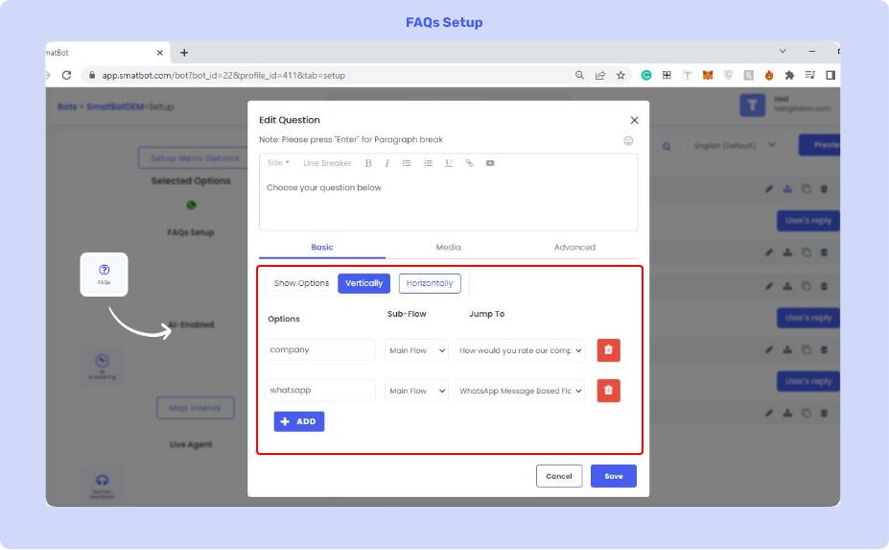
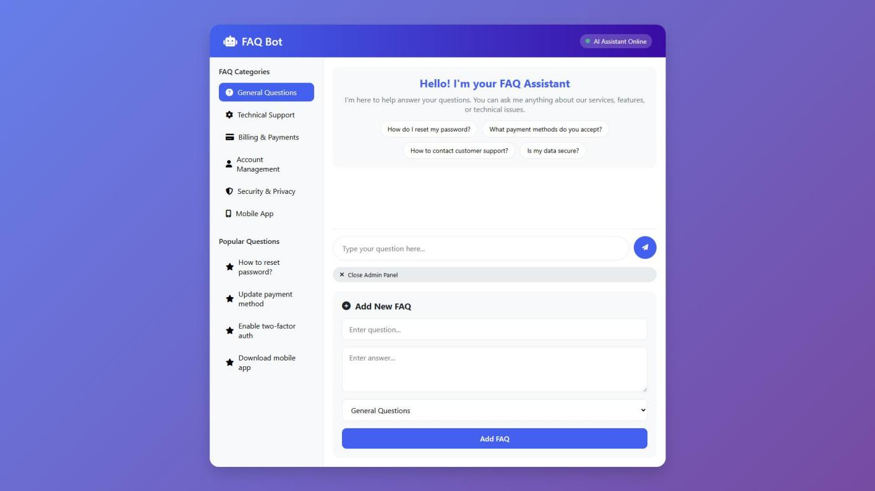

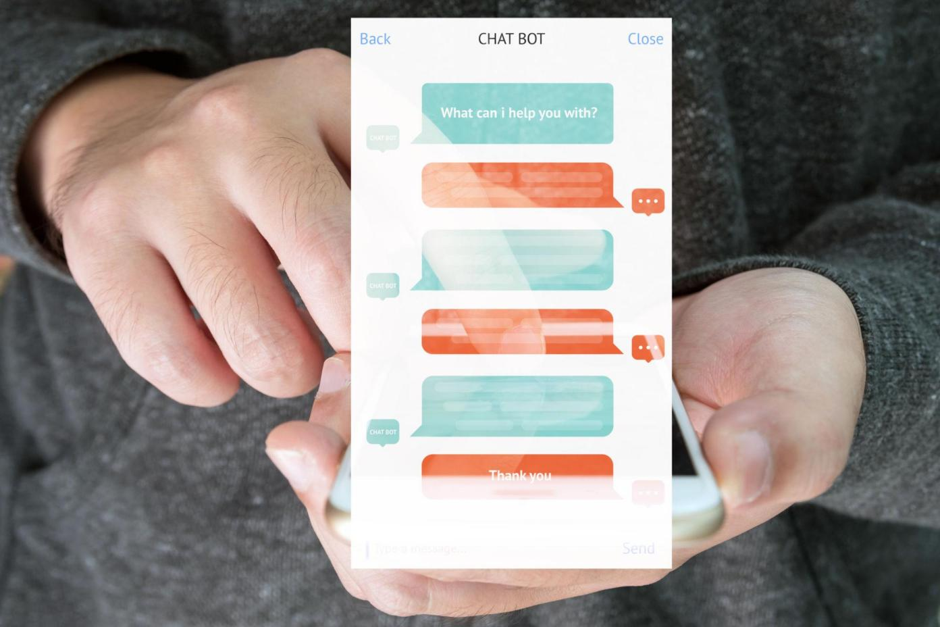
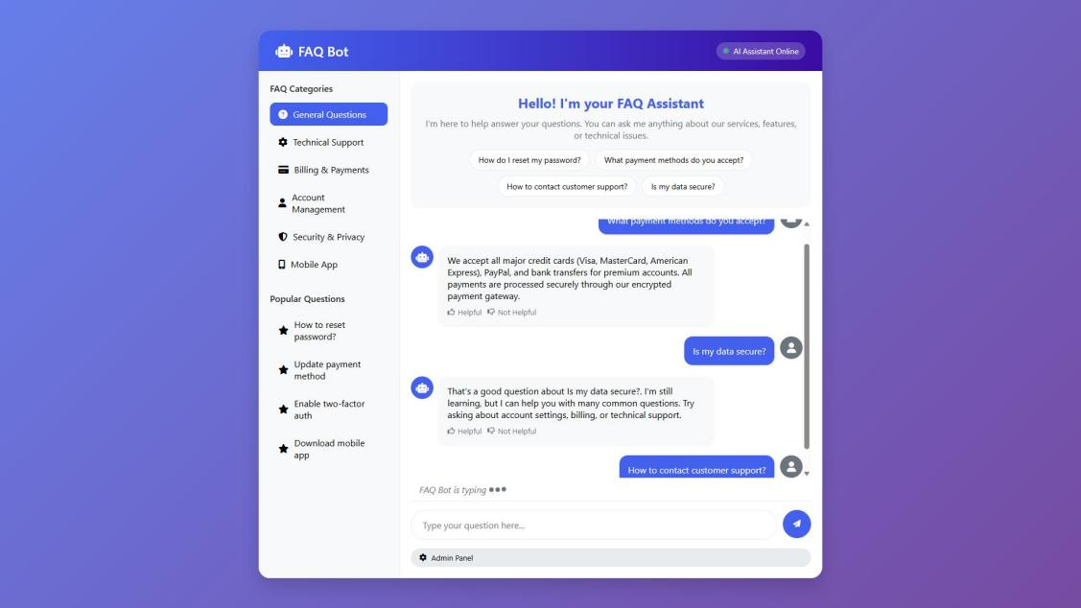
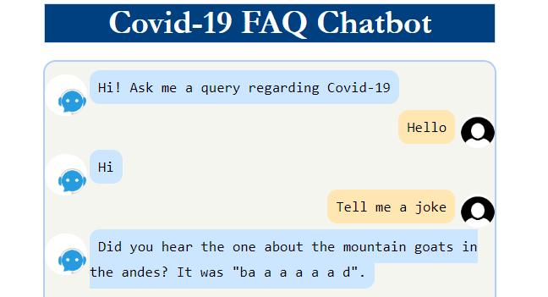
1️⃣1️⃣ Advantages
- Provides instant responses.
- Reduces manual customer support work.
- Improves user experience.
- Supports automation.
- Easy to use interface.
- Fast and accurate matching.

1️⃣2️⃣ Challenges Faced
During development several challenges were faced:
- Preprocessing user questions correctly.
- Improving similarity matching accuracy.
- Handling unrelated user questions.
- Designing a responsive chatbot interface.
These challenges were solved through testing and debugging.

1️⃣3️⃣ Future Enhancements
The following features can be added in future:
- Voice-based chatbot
- Multilingual chatbot support
- Database integration
- Deep learning-based chatbot
- User authentication system
- Live customer support integration

1️⃣4️⃣ Conclusion
The Smart FAQ Chatbot was successfully developed using Python, NLP, and cosine similarity techniques. The chatbot provides accurate and real-time answers to user questions through a professional and attractive interface.
This project helped in understanding practical Artificial Intelligence concepts such as Natural Language Processing, text preprocessing, similarity matching, and chatbot development.
The chatbot successfully fulfills all project objectives and demonstrates the real-world application of AI in automated customer support systems.

1️⃣5️⃣ References
- Python Official Documentation
- NLTK Documentation
- Scikit-learn Documentation
- Streamlit Documentation
- CodeAlpha Internship Guidelines

